Case Study 14
European company status

Situation

The central management of the following European groups of companies decided to open negotiations with the employees to integrate each group into one European Company

Name of  Group | Number of employees |  |  |  |  | Country of origin | EWC
Name of  Group | UK | GERMANY | FRANCE | GREECE | POLAND | Country of origin | EWC
“Brit” | 10.000 | 2.000 | 3.000 | 500 | 3.000 | UK | No
“Alem” | 2.000 | 20.000 | 2.000 | 400 | 4.000 | GERMANY | Yes
“Fra” | 1.000 | 1.000 | 22.000 |  | 1.000 | FRANCE | Yes
“Gre” | 500 | 1.000 | 600 | 6.000 | 1.000 | GREECE | No
“Pol” | 3.000 | 4.000 |  | 4.000 | 8.000 | USA | No

Task

You represent first the employee’s side and then the employer’s side of each group.
Describe the expectations of both sides in the followings
- Structure of the company (e.g. monistic or dualistic system)
- Role of employees representatives
- Role of trade unions
Take into consideration that in Europe there are two types of workers representation systems (through trade unions or through work councils) and also the strength of the local trade unions in the country of origin.
Also there are two types of company management systems (monistic with one board of directors e.g. U.K. and dualistic with management board and supervisory board e.g. Germany).

FR
ES
PT
UK
IE
IS
NO
SE
FI
EE
LT
PL
CZ
SK
HU
IT
GR
AT
DE
NL
DK
SI
BE
LV
LU
LI
Monistic Structure (15)
⇒ Board of Directors
Dualistic Structure (8)
⇒ Management board and supervisory board
Choice (7)
Monistic vs. Dualistic structure in Europe (EU-27+3)
Broad Level Representation system is more widespread in two-tier systems (but not limited to)

BG
RO
MT
CY

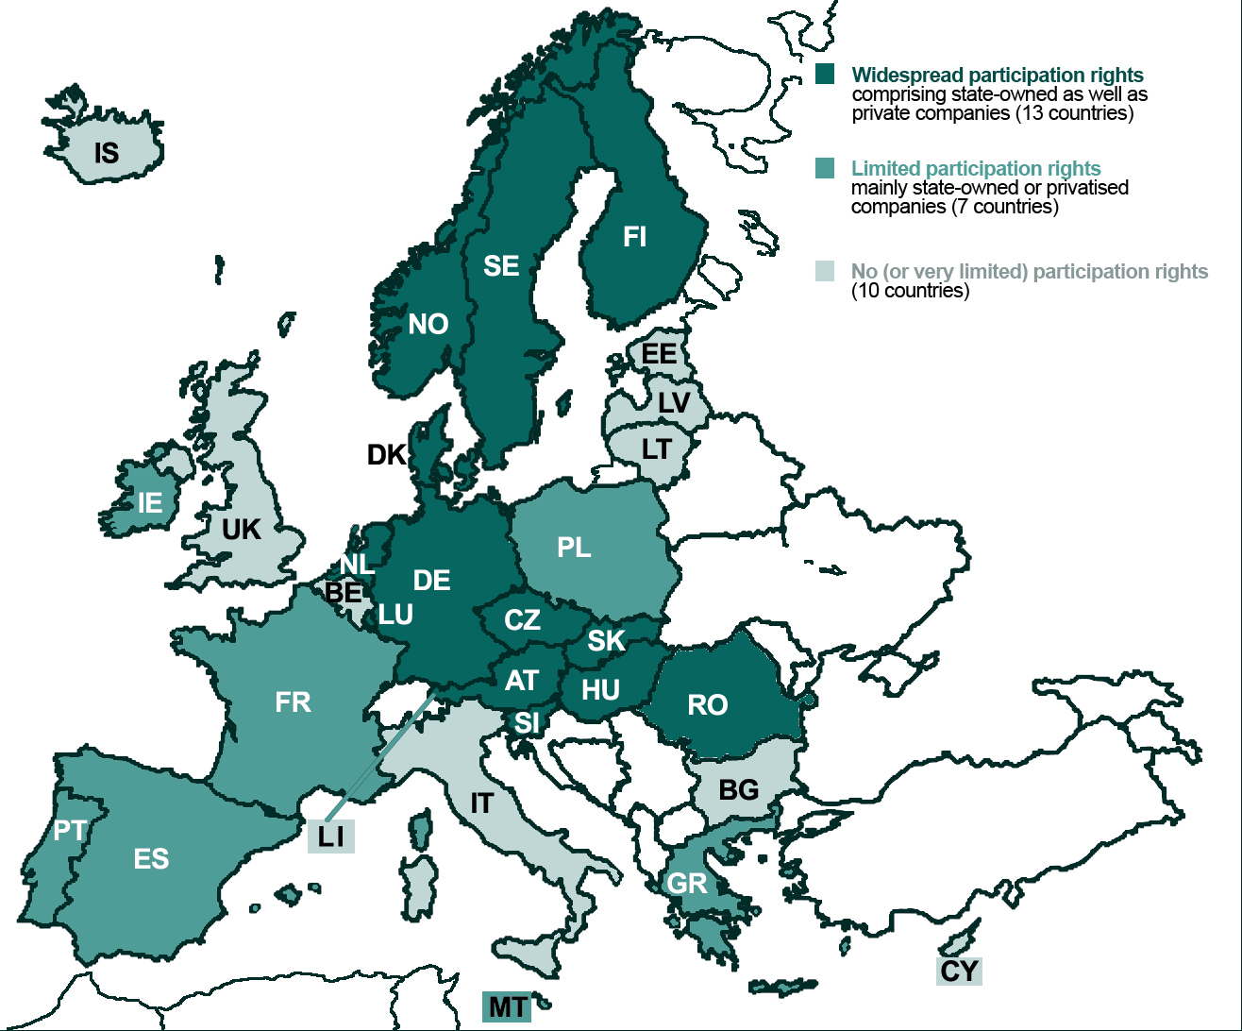
A first glance: The European map of board-level representation
ETUI-REHS: 2007
(Board-level) representation rights in the 30 countries applying the SE legislation
A feature known to many national corporate governance and interest representation systems

